
a
Company
Logotype

Cone Beam Computed Tomography- Report



Porur Dental X-rays & CBCT

Patient Name : Mr. Sivaramakrishnan | Date of Report : 14.04.2024
Age/ Gender : 33 years/ Male | Region of Interest : CBCT Maxilla
Referring doctor: Dr. V. Shanmugapriya | Indication : Implant assessment
Clinical Notes: Nil
PATIENT INFORMATION

CBCT- Maxilla provided
CBCT – IMAGE DETAILS

RADIOGRAPHIC INTERPRETATION

- Completely missing crown and root portion in relation to 14, 16, 25, 26.
- The maxillary alveolar ridge is present with normal trabecular pattern.

IMPLANT ASSESSMENT

 | 14 region
Sub-Crestal | 6.77
Mid- Crestal | 7.67
Distance between the alveolar ridge and Floor of the Nasal cavity (in mm) | 13.45

 | 16 region | 25 region | 26 region
Sub-Crestal (in mm) | 11.66 | 7.69 | 11.08
Mid- Crestal (in mm) | 12.09 | 9.78 | 10.89
Distance between the alveolar ridge and floor of the maxillary sinus (in mm) | 4.46 | 18.74 | 8.28

RADIOGRAPHIC IMPRESSION

- Partially edentulous maxillary arch.

Kindly correlate with clinical findings


IMAGES FOR REFERENCE

RECONSTRUCTED PANORAMIC VIEW
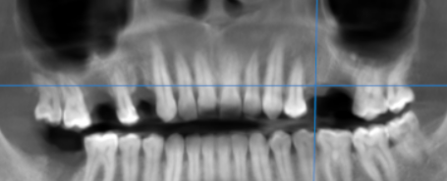

3-DIMENSIONAL VIEW

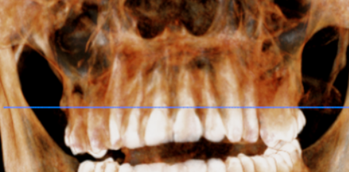

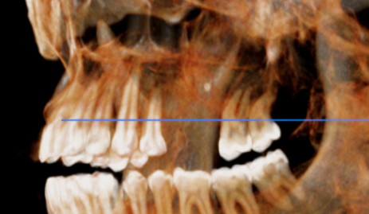

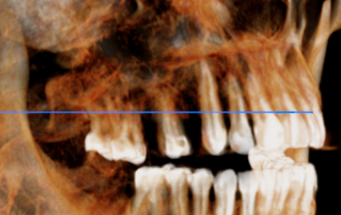

CROSS SECTIONAL VIEW

14 region | 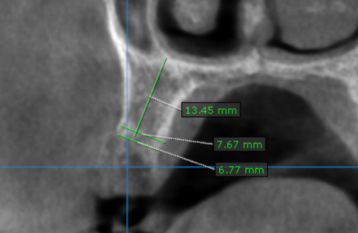
16 region | 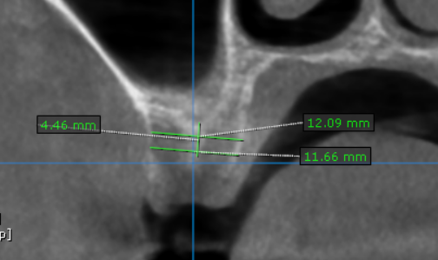
25 region | 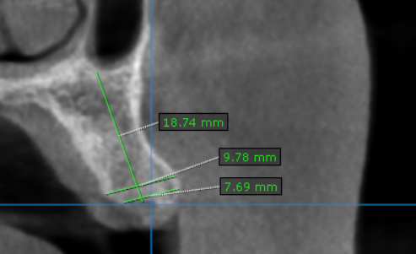
26 region | 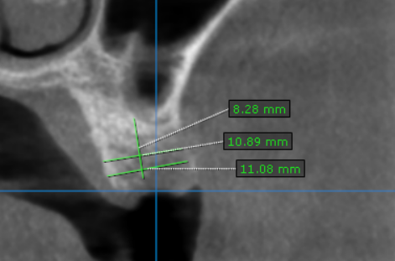

**** End of report ****

